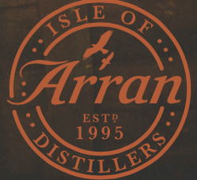Isle of Arran

Client Sales Checklist

Salesperson Name_______________________________________________

Date:______________________

Manager Approval Requirement

______________________ The client has already completed an Isle of Arran NDA.

Initial

______________________ The client is being provided the cask offer terms and

Initial conditions prior to viewing the order form.

______________________ The client likes to drink whiskey.

Initial

______________________ I have not consumed too much of this product prior to

Initial approving this checklist.

______________________ I promise that I have reviewed each of these items with

Initial the salesperson.

Manager Date

Director Date